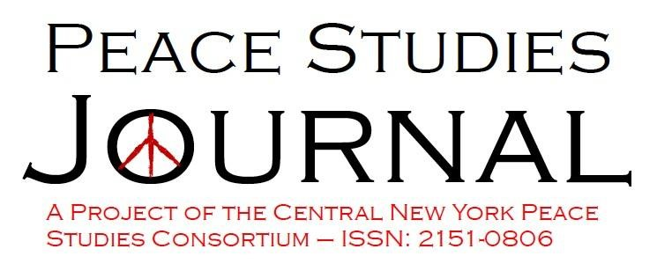
PEACE STUDIES JOURNAL: AUTHOR’S CONTRACT
_____________________________________________________________________________

AGREEMENT between Author and Peace Studies Journal

(NOTE: If the piece is co-authored each author must fill out separate Agreement.)

Title of work submitted: Click here to enter text.

Author(s): Click here to enter text.

Name: Click here to enter text. Phone: Click here to enter text. Fax: Click here to enter text.

Address: Click here to enter text.

E-Mail: Click here to enter text.

Type of work submitted to PSJ: ☐ article/essay ☐ book/ film/ other media review

☐ interview/dialogue ☐ event review ☐ commentary ☐ notes ☐ curriculum

☐ other Click here to enter text.

Name of all authors in the order in which they appear in the work submitted
Click here to enter text.

Terms of the Agreement

- Application: The terms of this Agreement shall apply to all works of authorship or invention, whether
photographic, literary, artistic or otherwise (the “Work Submitted”), prepared by you (the “Author”) for submission to us (Peace Studies Journal (PSJ)).

- Copyrights: By entering into this agreement, you warrant that this submitted work:
  - Is an original work; that the work has been submitted only to this journal and that it has not been submitted or published elsewhere;

  - That you have obtained permission from the copyright holder to reproduce in the work submitted (in all media including print and electronic form) material not owned by you; that it will in no way infringe upon any copyright or proprietary rights of others;

  - That the work submitted does not contain any unlawful, or libelous statements, and that it will not be in violation of any right of privacy;

  - The Author also agrees to hold Peace Studies Journal (PSJ), Central New York Peace Studies Consortium and its officers, directors, agents, employees, staff, volunteers, and the State of New York harmless from any and all liability, expenses or damages arising out of the contents of the Author's work, or the publication of any unlawful matter contained therein, excepting, however, any matter added upon the request of Peace Studies Journal (PSJ).

  - You warrant that in the case of a co-authored submission, you have obtained authorization to enter into this Agreement on their behalf, and that the co-authors have read and agreed the terms of this Agreement.

  - The Author's signature (written or displayed in electronic form) on this agreement will constitute an exclusive grant to the publisher of a complete release of all publishing and proprietary rights regarding the Author’s Submitted Work in book form and in non-book format; in all languages throughout the world, and for the original and all subsequent editions and printings of the book.

- Re-publication of the Author's work submitted may be assessed for a reasonable fee concerning the administration and facilitation to other presses. Such fee shall be determined at the discretion of the Peace Studies Journal (PSJ).

- Royalties: the Author agrees and acknowledges that no royalty, payment, or other compensation will be provided by Peace Studies Journal (PSJ) in exchange for or resulting from the publication of the Submitted Work.

Please note: You have the right to re-use the work submitted, as long as you do not sell or reproduce any part of it for publication or commercial purposes. You may freely share print or electronic copies of your work submitted in personal compilations; with colleagues, or for educational or research purposes (including course packs). _________________________________________________________________________________________
Terms agreed to and accepted:

Print name: Click here to enter text. Date: Click here to enter a date.
Electronic Signature (on behalf of all co-authors (if any))—Please type your First and Last Name

Click here to enter text.
☐I understand that checking this box constitutes a legal signature confirming that I acknowledge and agree to the above Terms of the Agreement.
___________________________________________________________________________________________
Please return the completed and signed form by e-mail to:
Dr. Anthony J. Nocella II
nocellat@yahoo.com

* PSJ Contract updated August 2016.

